2026
Nutrient Management Plan
Gruber Livestock North

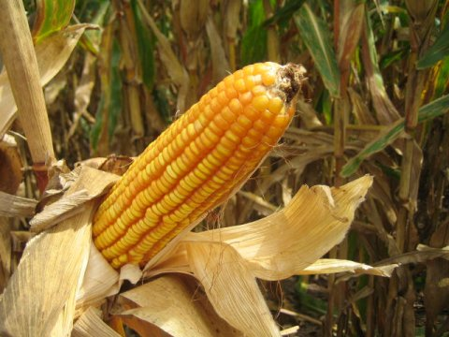

Plan Completed by:
R. Roger Geisking, CCA 25707
AgSource Laboratories
P. O. BOX 7
Bonduel, WI 54107
Office: (715) 758-2178
Cell: (608) 516-9247

